|  |
| --- |
| Circle Language Spec: Commands |

## Private Objects in an Active Clause in a Diagram

This article demonstrates a situation of command objects.

This article illustrates how private objects in an active clause look in a diagram.

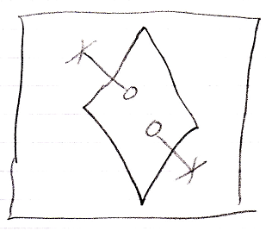

The large square is a command definition, the clause is in. The diamond inside the square is the active clause. It contains two circles, which are the private objects of the active clause. The lines that go outside, that end at a cross are the indications that the objects are private. They indicate you can not reference the circles from the outside.

Another possible expression of the private objects is the following:

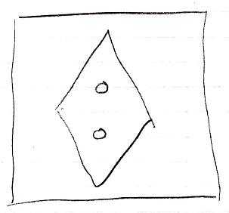

Because public object, parameters, always come with an indication of the parameter passing, you may not need to express the objects’ being private, because it would be obvious: if they do not have a parameter passing, then they are private.